Data Flow Descriptions

Name – Hritik Anand

Student ID – 10485477

Unit- INF 20015 Requirement Analysis and Modelling

Data Fragments

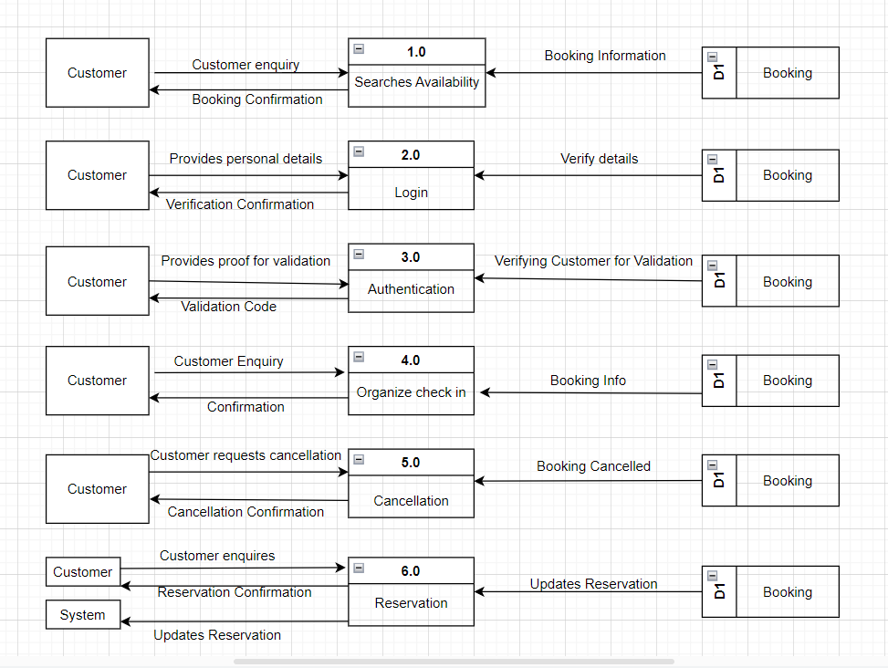

Logical Data Dictionary

1. **Customer searches availability**

|  |  |  |
| --- | --- | --- |
| Data Flow Name | Items | Description |
| Input Data | Enquiry_Type + C_First_Name + C_Last_Name + C_Telephone | Data entered by the customer to initiate an enquiry |
| Enquiry Handling | Enquiry_ID + Enquiry_Type + C_First_Name + C_Last_Name + C_Telephone + Time_Strap | Process of handing customer’s enquiry |
| Data Access | Enquiry_ID + Enquiry_Type + Time_Strap + Customer Information | The process of accessing enquiry and response data |

1. **Customer Login**

|  |  |  |
| --- | --- | --- |
| Data Flow Name | Items | Description |
| Input Data | = C_Username + C_Email + C_Password | Data entered by customer to initiate login |
| Input Validation | = C_Username + C_Password + Validation result+ Time_Strap | Process of validating the input data to ensure that the login process is secure. |

1. **Authentication**

|  |  |  |
| --- | --- | --- |
| Data Flow Name | Items | Description |
| Input Data | = C_Username + C_Password | Data entered by customer to initiate authentication request |
| Authentication process | = C_Username + C_Password + Time_Strap +Authentication result | Process of verifying customer’s identity by matching the provided credentials with those stored In the system’s database |
| Output Data | = Authentication result + Access_Code + Time_Strap | The output data retured to the customer after the authentication process is complete |

1. **Organize check – in**

|  |  |  |
| --- | --- | --- |
| Data Flow Name | Items | Description |
| Input Data | Booking_ID + Customer Information( Customer ID + C_First_Name etc.) | Data entered by customer to initiate the check - in process |
| Check in process | Booking_ID + Customer Information + Time_Strap | Process of verifying customer booking and personal information in order to organize safe check – in |
| Output Data | Check - in status + Time_Strap | Output data retured to the customer after the check – in is complete |

1. **Cancellation**

|  |  |  |
| --- | --- | --- |
| Data Flow Name | Items | Description |
| Input Data | Booking_ID + Customer Information + Reason for cancellation | Data entered by customer to initiate the cancellation process. |
| Cancellation Process | Booking_ID + Customer Information + Cancellation_Status + Time_Strap | Process of verifying customer’s booking and personal details for the cancellation of the reservation. |
| Output Data | Cancellation_Status + Cancellation Confirmation + Time_Strap | Output data returned to the customer after the cancellation process is complete |

1. **Reservation**

|  |  |  |
| --- | --- | --- |
| Data Flow Name | Items | Description |
| Input Data | Customer Information + Reservation Details | Data entered by customer to initiate reservation process |
| Reservation Process | Customer Information + Reservation Details + Reservation Status + Time_Strap | Process of verifying customer’s reservation. |
| Output Data | Reservation Status + Reservation Confirmation + Time_Strap | Output data returned t the customer after the reservation is complete. |

Physical Data Dictionary

|  |  |  |  |  |  |
| --- | --- | --- | --- | --- | --- |
| Data Dictionary- Customer Information | | | | | |
| P/F | Field Name | Caption | Data Type | Field Size | Description |
| P | Customer_ID |  | Auto Number |  |  |
| F | Booking_ID | Usual Order No. | Long Integer | 20 |  |
|  | C_First_Name | First Name | Text | 20 |  |
|  | C_Last_Name | Last Name | Text | 20 |  |
|  | C_House_Add | House Address | Text | 25 |  |
|  | C_Street | Street | Text | 25 |  |
|  | C_Town | Town | Text | 20 |  |
|  | C_Post_Code | Post Code | Text | 9 | >LL0990LL |
|  | C_DOB | Date of Birth | Date/Time | 10 | Dd mm yy |
|  | C_Telephone | Telephone No. | Integer | 15 | (00000) 000 000 |
|  | Enquiry_Type | Customer’s Enquiry | Text | 100 |  |
|  | Enquiry ID | Enquiry ID | Auto Number |  |  |
|  | C_UserName | Customer’s Username | Varchar |  |  |
|  | C_Password | Customer’s Password | Varchar |  |  |
|  | Time_Strap | Date and time value of specific record | time |  | 00:00:00.0000000 through 23:59:59.9999999 |

Structured English

**Process 2.0, 2.1 Login and Required Assistance**

|  |  |
| --- | --- |
| Sub-Process Name | Description |
| Customer Login/ Requires Assistance | If (Customer wants to open an account)  Input User Information name  Verification  Open Account  Elif (Customer already has an account)  Input Password  Ask for identification information.  Query database with identifying information  Endif (Forgot password/ Requires Assistance)  Follow authentication steps  Verify new details  Endwhile |